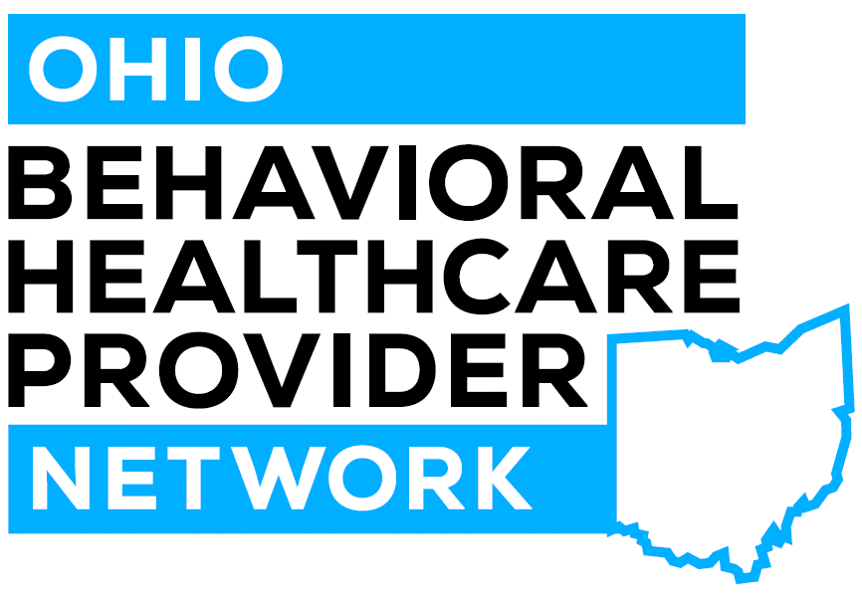 | NEW MEMBER APPLICATION

Thank you for your interest in joining the Ohio Behavioral Healthcare Provider Network (OBHPN) -
Application for Network Membership
Please complete and return this application to Katy Smith at Katy.Smith@shcare.net.
The OBHPN Board will consider your application. Completion of the application is not a guarantee of acceptance. If accepted, we will contact you with the appropriate corporate documents for completion.
Organization Name: | Click or tap here to enter text.
Address: | Click or tap here to enter text.
Tax ID Number: | Click or tap here to enter text.
NPI Number(s) | Click or tap here to enter text.
Corporate Owner/ Affiliation: | Click or tap here to enter text.
Contact Name: | Click or tap here to enter text.
Contact Email: | Click or tap here to enter text.
Contact Phone: | Click or tap here to enter text.
CEO and #Email | Click or tap here to enter text.
How many unique clients does your organization serve annually? |  |  | Click or tap here to enter text.
Does your organization serve both adult and pediatric populations? |  |  | Yes No
Does your organization provide MH services? If yes, specify age ranges.  ____________________________________________________________ |  |  | Yes No
Does your organization provide AOD services? If yes, specify age ranges.  ____________________________________________________________ |  |  | Yes No
What percentage of your clients served are SPMI (severe and persistent mental illness)? |  |  | Fewer than 25%  Greater than 50%  Greater than 75%
Which EMR(s) does your organization use? |  |  | Click or tap here to enter text.
Does your organization use Clinisync? If yes, which functions?  ____________________________________________________________ |  |  | Yes No
Is your organization accredited by one of the following bodies? If other, please specify. |  |  | CARF  The Joint Commission  COA  Other
Is or/has your organization been a CCBHC grant recipient under SAMHSA? |  |  | Yes No
Does your organization provide primary care services directly? |  |  | Yes No
Does your organization provide primary care through outside affiliation/contract? |  |  | Yes No
If yes, please describe your model below:
Click or tap here to enter text.

If your organization provides primary care, which of the following describes you best? |  |  | FQHC  FQHC look alike  RHC  Other
Which of the following BH services does your organization directly provide? If other, please specify.  ____________________________________________________________  ____________________________________________________________  ____________________________________________________________  Which of these services does your organization provide via a contract with another provider? Please specify.  ____________________________________________________________  ____________________________________________________________  ____________________________________________________________ |  |  | Counseling  Case management  Medication Management  24/7 Crisis Intervention  Day Treatment  Homeless Services  Housing  Peer Support  Employment  Residential  MAT/MOUD  Prevention  Other
Please list the geographic areas your organization covers (counties and part of counties)
Click or tap here to enter text.

Mandatory Participation Criteria: Please indicate your ability to participate in network contracting and quality requirements (required of subcontracting agents):
- Organization will participate in at least 80% of negotiated contracts. |  | Yes No
- Organization will comply with all OBHPN quality program requirements. |  | Yes No
- Members of organization will be required to actively participate in OBHPN Board committees and subcommittees. |  | Click or tap here to enter text.

